Business Plan Template
Courtesy of @stevenfies
Based on my book, 24-Hour Business Plan Template
Find more information at stevenfies.com.

Plan Summary

- Cover Page
- Executive Summary
- Company Objectives
- Products & Services
- Customer Analysis
- Competitor & Industry Analysis
- Sales & Marketing Strategy
- Operations & Logistics
- Management Structure
- Business Capitalization
- Financial Plan

(Your logo here ^)

Executive Summary

(Your summary here)
Lorem ipsum dolor sit amet, consectetur adipiscing elit. Vivamus venenatis, mi nec imperdiet imperdiet, erat nibh blandit velit, viverra rutrum diam turpis nec orci. Mauris sodales odio sed blandit viverra. Quisque ultrices, felis cursus volutpat lacinia, leo justo tempus arcu, id gravida dui dolor a dolor.
Donec tincidunt eros vel justo ultrices, auctor iaculis risus mollis. Sed finibus nisl non nulla convallis, eget blandit lorem molestie. Vivamus venenatis sapien id facilisis semper. Sed ac quam sed nunc aliquet ullamcorper. Duis sollicitudin est velit, vel sagittis dolor bibendum quis.
Remember to include:
- The names of the owners of the business.
- The location(s) of the business.
- Startup capital required to launch, and a brief description of how it will be used.
- A rough timeline for the business – estimated launch date, growth milestones, and a brief description of what things look like a few years down the road.

Company Objectives

- Mission Statement
  - (Your text goes here)

- Guiding Principles
  - (Your text goes here)

- Owners & Legal Structure
  - (Your text goes here)

- Industry
  - (Your text goes here)

- Brief Review of Products, Services, & Customer Profile
  - (Your text goes here)

- Primary Business Objectives
  - (Your text goes here)

- Consolidated Financial Forecast
  - (Your text goes here)

4. Products & Services

Product/Service #1
- WHAT is it?
- WHO will buy it?
- WHY will they buy it?
- WHEN will they use it?
- WHERE will it be used?
- HOW does it stack up against market substitutes (competing products)?

Product/Service #2
- WHAT is it?
- WHO will buy it?
- WHY will they buy it?
- WHEN will they use it?
- WHERE will it be used?
- HOW does it stack up against market substitutes (competing products)?

5. Customer Analysis

- Who is your customer?

- Demographic profile (age, location, interests, etc.)?

- Where do your customers get information about products and services like yours?

- Where is your average customer employed? Be specific – include the type of industry they work in, if applicable, along with their job title and function.

- What does your customer do in their free time?

- What guiding principles, beliefs, and values does your customer hold?

- Describe the average day in the life of your customer.

6. Competitor & Industry Analysis

Industry Analysis
  - Market Size ($) –
  - Market Growth –
  - Market Demand –
  - Market Trends –
  - Barriers to Entry –

Competitor Analysis

 | YOU | Competitor #1 | Competitor #2
Products
Price
Customer Svc
Comp Advantages
C. Disadvantages
Market Share
Customer Loyalty

7. Sales & Marketing Strategy

Graphically show your sales/marketing funnels here:
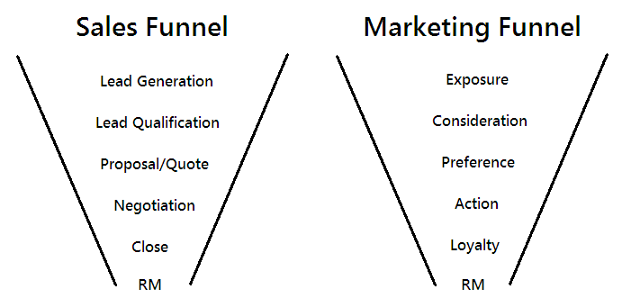

List Marketing Costs
- Lead & Market Research –
- Graphic Design –
- A/B Experimentation –
- Media Production –
- Web Optimization & SEO –
- Hard Costs charged by advertisers to run your ad –
- Trade Show Exhibitor Fees –

List Sales Costs
- CRM Software (like SalesForce) –
- Cell Phone and/or Company Car (for outside sales) –
- Prospecting Lists –
- Training (if you’re hiring newbies) –
- Trade Show Exhibitor Fees –
- Fun Company Events, Bonuses, and Incentives (to keep salespeople motivated) –
Sales & Marketing Data Table
 | Cost/Month | Expected ROI | Time to Build
Niche Magazine Ad
Online PPC Campaign
Outbound Sales Calls
Content Marketing
Etc.

8. Operations & Logistics

- Production
  - Raw Materials –
  - Suppliers –
  - Quality Control –
  - Production Methods –
  - Inventory Management (if applicable) –

- Staff
  - Job Descriptions –
  - Hiring Strategy –
  - Compensation –
  - Organizational Structure –
  - Company Procedures –
  - Schedules –

- Legal
  - Licenses and Permits –
  - Conformity to Government Regulations –
  - Insurance –
  - Workplace Laws – such as OSHA –
  - Intellectual Property –
  - Legal Advice –

- Financial
  - Accounting Methods –
  - Reporting Requirements –
  - Tax –
  - Establishment of Company Financial Accounts –
  - Company Credit Policies –
  - Management of Accounts Receivable and Payable –
  - Accountant/CPA –

9. Management Structure

Discuss structure here, being sure to include/list the following:
- Owners
- Board of Directors
- C-Level Executives (CEO, CFO, COO)
- Managers
- Supervisors

- Attorney
- Accountant
- Investors Advisors
- Business Consultants
- Financial Advisors
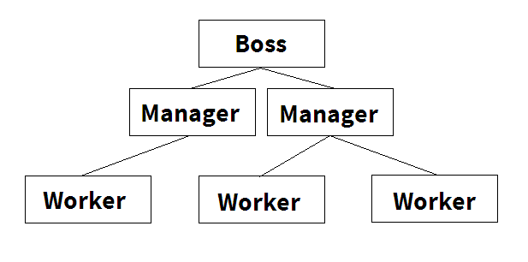
Show org chart here:

10. Business Capitalization

List business capitalization source(s) here.
- Source 1 – Amount of Capital
- Source 2 – Amount of Capital
- Etc.
List all startup costs here:
- Business Registration & Licensing
- Professional Legal & Financial Advice and Assistance
- Communications & Network Expenses (Internet, Phones…)
- Location: Rent, Water, Utilities, Garbage
- Web Hosting, Design, and Development
- PP&E – Property, Plant, and Equipment
- Initial Inventory
- Insurance & Bonding
- Logo Design, Marketing Materials
- Starting Payroll
- Miscellaneous Expenses

11. Financial Plan

Business Financial Plan
- Financial Snapshot upon Launch

- 1-Year Profit Projection

- 5-Year Profit Projection

- Estimated Cash Flow

Personal Financial Plan
- Current personal assets/net worth

- Current personal liabilities/debts

- Current financial situation/sustainability plan

- Estimated Cash Flow (Personal)

